STUDENT HANDOUT – UNIT 4: POLK COUNTY FLOOD SCENARIO

Current Operational Period:

August 5, 0600 – 1800

Next Operational Period:

August 5, 1800 – August 6, 0600

Purpose:

Select tactics and conduct safety analysis for the next Operational Period, resulting in the completion of ICS Forms 215, Operational Planning Worksheet, and 215A, Safety Analysis. Students may use the tactics meeting agenda as a template when conducting group discussions.

Instructions:

- Review the scenario update and ICS Form 201, from Unit 3.

- Within your Incident Management Teams, complete ICS Form 215 using the
available information.

- Three areas are affected: Peace River Village, Bartow Tee Street, and Fort Meade
Mobile Home Park.

- Based on the tactics selected on the ICS Form 215, complete the ICS Form 215A, Safety
Analysis.

- A safety analysis should be conducted for each work assignment selected on the ICS
Form 215.

6. Update your organizational chart to reflect any necessary changes.

7. Based on the work assignments identified on the ICS Form 215, prepare a list of
resources you would need to order to fulfill your desired objectives. (Resource ordering will be covered in Unit 6).

8. The PIO should be prepared to discuss and rationalize your decisions in 80 minutes.

Scenario Update:

The National Weather Service has just informed the County Emergency Management Division that flooding along the Peace River is expected to crest around 1800 (6:00pm) today. It is expected that this crest will cause significant flooding in the indicated areas of the map and could impact multiple roads and bridges.

Incident Command determines additional resources are needed for evacuation, sheltering, sandbagging, water level and chemical monitoring, traffic control, and scene security. Also, several media helicopters arrive in the area to film the incident and ongoing operations. Command has determined the operational period will be 12 hours. The next operational period will begin at 1800 tonight and end at 0600 August 6.

Residents in the Peace River Village from 1st Street to 5th Street are being asked to evacuate their homes in anticipation that the rising floodwaters may cut off access to and egress from their homes. Flooding deeper than three feet along Front St. is anticipated.

Some residents in Bartow are under a mandatory evacuation that extends from Tee Avenue to Tee Avenue S. to E. Tee Circle, and flooding is expected at the Bartow wastewater treatment plant on E. Wabash Ave.

Fort Meade residents are under a voluntary evacuation that extends from S. Washington Avenue east to Edgewood Drive S and E. Broadway Street south to Oakwood Drive.

The Fort Meade Nursing Home is asking for assistance to move 55 patients from their skilled nursing care facility. Mid Florida Diesel, located off Highway 60 near Peace River, is reporting flooding near their warehouse which contains generators being repaired. They are not reporting any chemical releases but are closely monitoring their facility.

Resources are beginning to arrive at the Staging Area.

Several media trucks have arrived in the area to film the incident and ongoing operations. The Staging Area Manager reports press personnel are beginning to congregate in the Staging Area to film the resources located there.

Calls are coming from concerned citizens about the safety of the municipal drinking water.

Critical Tasks:

- Implement required safety measures to protect responding personnel and the public.
- Take measures to ensure the evacuation of all households in the projected flood area before the beginning of the next operational period.
- Implement a temporary shelter plan to provide housing for all displaced residents.
- Evacuate and relocate nursing home residents before the onset of flooding.
- Monitor water intakes at the water treatment plant for chemical contamination.
- Monitor river levels at the Bartow Wastewater Treatment Plant. Be prepared to activate the Continuity of Operations Plan (COOP).
- Provide timely and accurate safety information to the public through the Joint Information Center.

Strategies / Tactics:

The Fort Meade Nursing Home emergency plan calls for relocating patients to Bartow Hospital. This plan utilizes Polk County Fire Rescue ambulances and Polk County School Board school buses to transport patients. The American Red Cross, in collaboration with the Salvation Army, will manage the pet friendly and general population shelters and provide food for all shelters.

Polk County Utilities and Florida Department of Health in Polk County will monitor the water intake at the water treatment plant for signs of chemical contamination. Additional crews will monitor water levels at strategic points in the flood area, including but not limited to schools, fire stations, and sheriff/police stations in the potential flood areas. The County Engineer and Florida Department of Transportation will monitor the structural integrity of bridges. Bartow Public Works crews will place sandbags to protect the wastewater treatment plant. Individual homeowners can get free sandbags and sand from Polk County Roads and Drainage Division at four locations around the county.

Area near Peace River along Highway 60 in Bartow


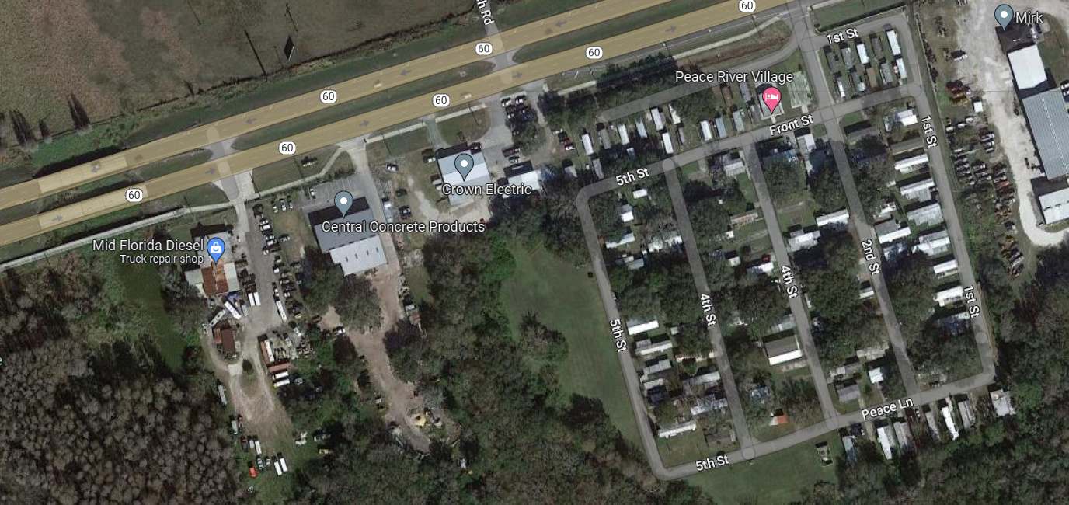

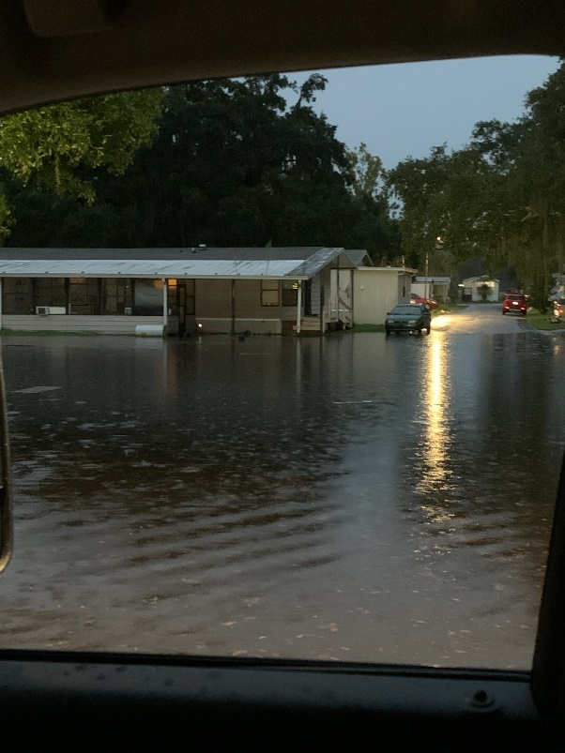
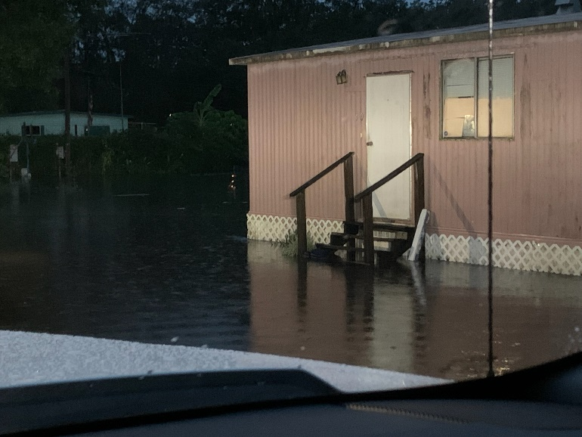

Bartow Wastewater Treatment Plant

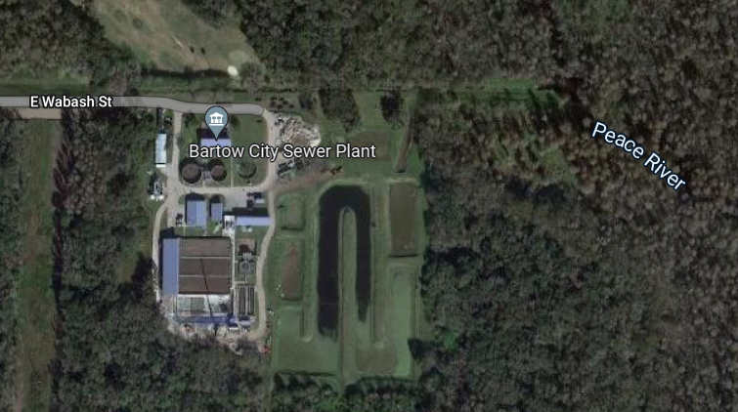



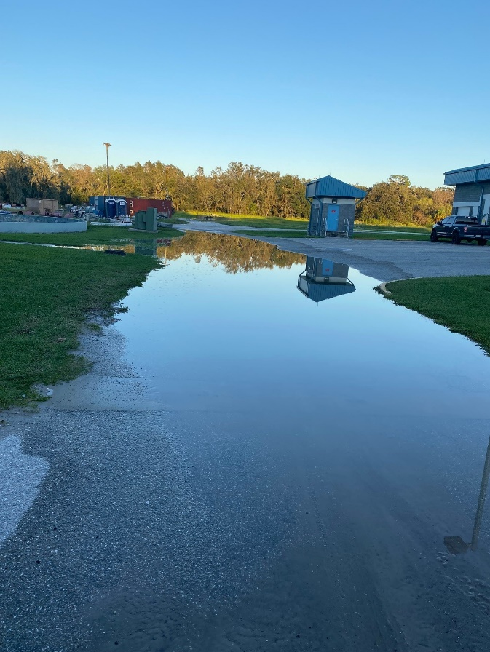

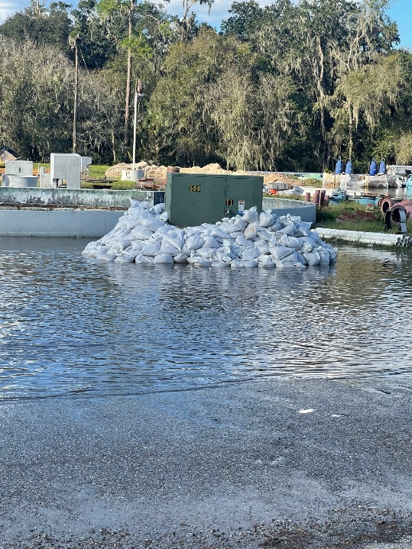
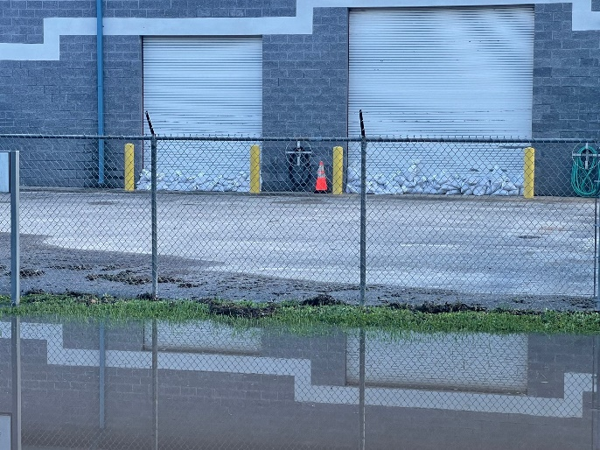
Bartow Neighborhood
(Photos are from E. Tee Circle)

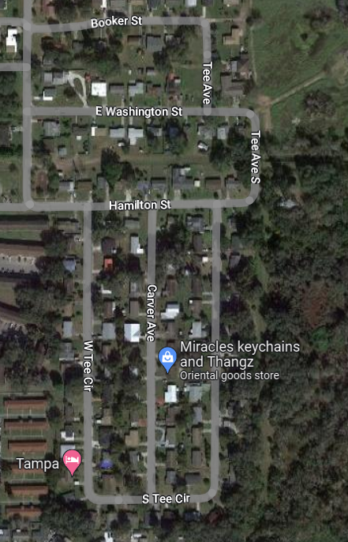

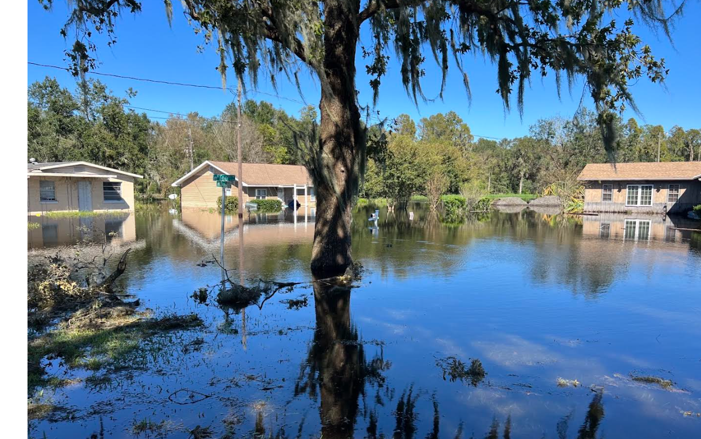

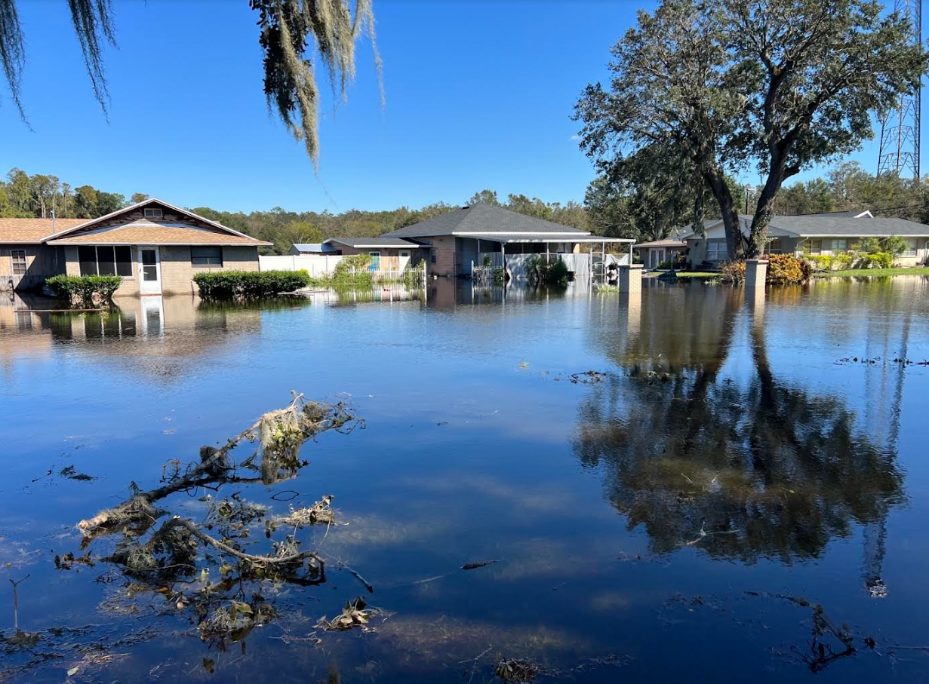

E. Tee Circle

Fort Meade Mobile Home Park and Nursing Home

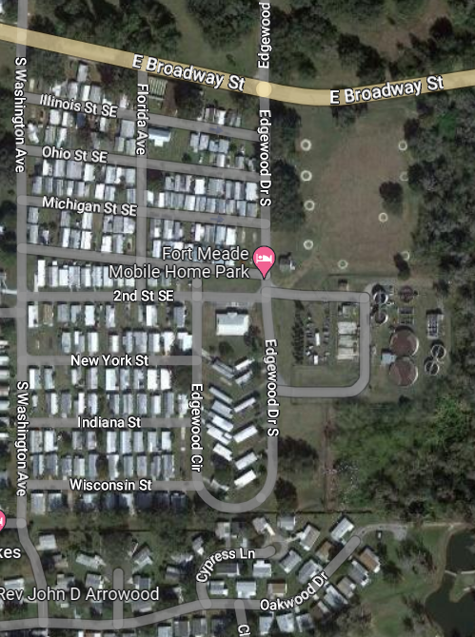
Nursing Home

