STUDENT HANDOUT – UNIT 2: POLK COUNTY FLOOD SCENARIO

Purpose:

The purpose of this scenario is to provide you an opportunity to apply what you have learned about fundamental ICS concepts to an incident involving a flood that has the potential to cause severe property damage and endanger human life.

Instructions:

Work in groups to complete the following activity:

1. Review the scenario, scenario map, and resource list on your handouts.

2. Complete the following steps:
- Identify who has a stake in the incident.
- Identify the assisting and cooperating agencies.
- Draw an organizational chart to support the objectives and manage resources. Your organization should maintain an effective span of control and include Command and General Staff, where appropriate.
  - If Single Command, who is the Incident Commander and why?
  - If Unified Command, who are the members and why?
- Identify 3 challenges and 3 safety issues.
- Describe the specific responsibilities delegated to the Command Staff and Sections that are activated.

3. Record your results on a chart or easel.

4. Select a Public Information Officer to present in 30 minutes.

Scenario-based activities are designed to help you apply what you are learning in this course. Although based on potential incidents, the scenarios have been altered to ensure that certain teaching points can be emphasized and work with the timeframe allocated. Therefore, the incidents and timing may differ from how you might experience the incident evolving in the jurisdiction or agency. It is important to focus on the learning activities rather than the details of the scenario.

Scenario:

Polk County is located in central Florida. It has been raining heavily for the past five days in Polk County, averaging 2-3 inches of rain each 24-hour period. Peace River is 106 miles long and originates at the juncture of Saddle Creek and Peace Creek northeast of Bartow and flows south through Fort Meade into Hardee County, Arcadia in Desoto County, and southwest into the Charlotte Harbor estuary at Punta Gorda in Charlotte County. US Highway 17 runs near and at times parallel to the river for much of its course.

In an effort to avoid damage and loss of life caused by the possibility of flooding along the two creeks and river, the Polk County Commissioners request your IMT to prepare a staffing plan for the response to anticipated flooding, if the rains do not stop.

Map:

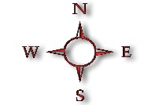
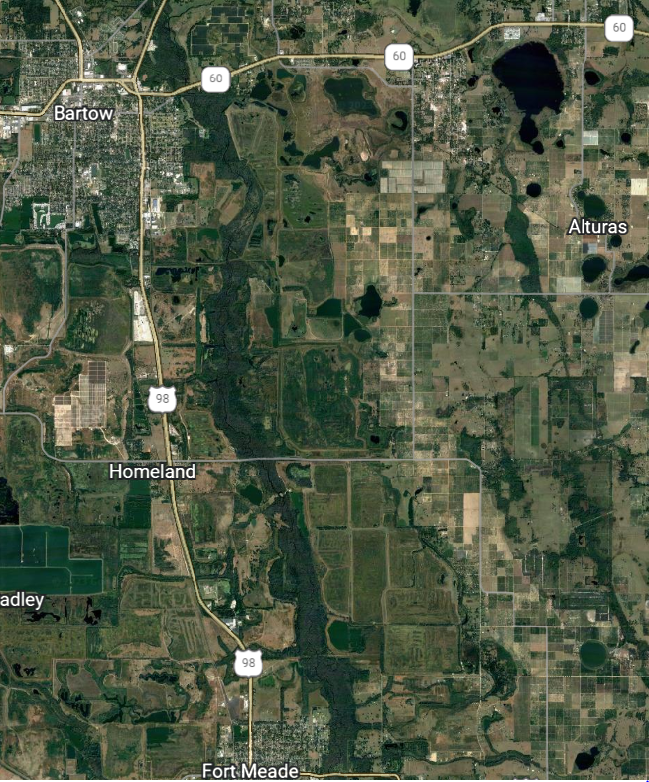
Homeland Bridge
Bartow Wastewater Treatment Plan
Tee Circle
Peace River Village
Fort Meade Mobile Home Park
John Singletary Bridge
Hwy 60 Bridge

FEMA Floodways noted in dark blue.

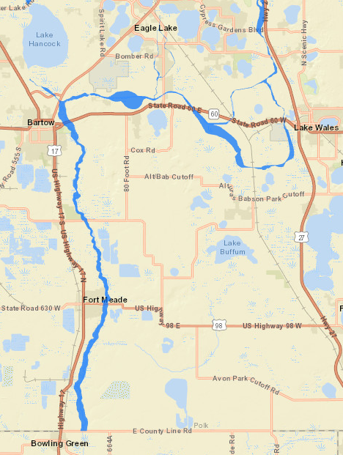

Current Resources Available:

- Polk County Emergency Management Team
- Polk County Emergency Operations Center (EOC)
- Polk County EOC Joint Information Center (JIC)
- Polk County Public Information Officer (PIO)
- Region 7 Type III, All-Hazards Incident Management Team (IMT)

- Law Enforcement:
  - Polk County Sheriff’s Office
  - Bartow Police Department
  - Lake Wales Police Department
  - Winter Haven Police Department

- Fire Department:
  - Polk County Fire Rescue
  - Bartow Fire Department
  - Lake Wales Fire Department
  - Winter Haven Fire Department

- Public Works/Utilities
  - Polk County Utilities
  - Bartow Public Works
  - Lake Wales Public Works
  - Winter Haven Public Works

